INTRODUCTION

MARVELOUS MANATEES

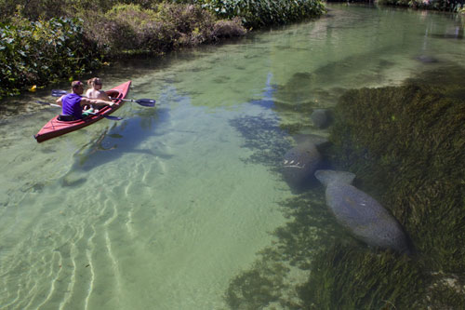
Many people may live their entire life and never hear of a manatee. They may never experience the awe and wonder of seeing these marvelous creatures up close and personal. Their life may continue from day to day with no thought of this peaceful endangered mammal. This author wants to change that! Everyone should know about manatees and how amazing they are. Everyone should think about what we can do to preserve them and keep them from becoming extinct!! Manatees are simply marvelous creatures that deserve to be heard.

