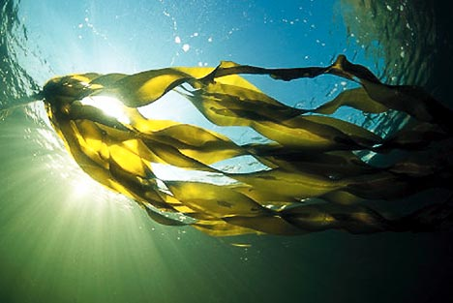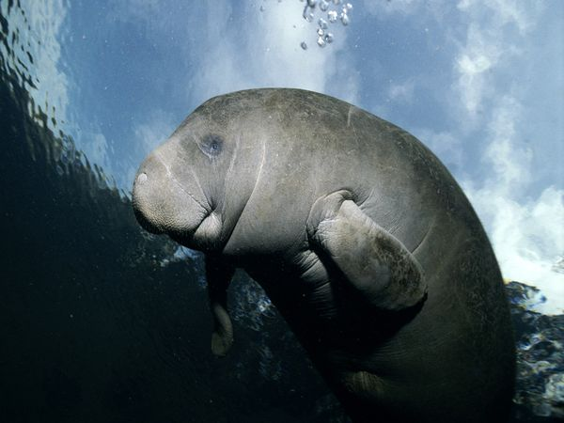

**By: Jodi Lombard**

**MAGNIFICENT**

**MANATEES**