CONCLUSION
MORE MANATEES PLEASE
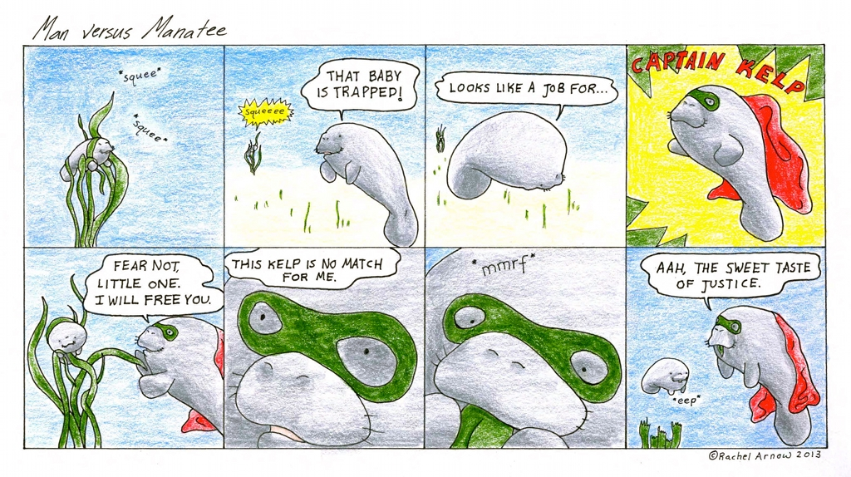
Manatees are unique and fascinating creatures. People can learn from their peaceful nature and their slow beauty. If more people were aware of their existence, then more people could work to help save them. People all across the country and the world are doing things to raise awareness and to raise money to help the manatees. Some people have organized 5k and 10k runs to raise money. Others have filmed documentaries for film school projects. There are so many things that can be done to help. What will you do to help this magnificent creature have a future??

